**Focal Inquiry Question** (e.g., “How can we …

Webinar Notes

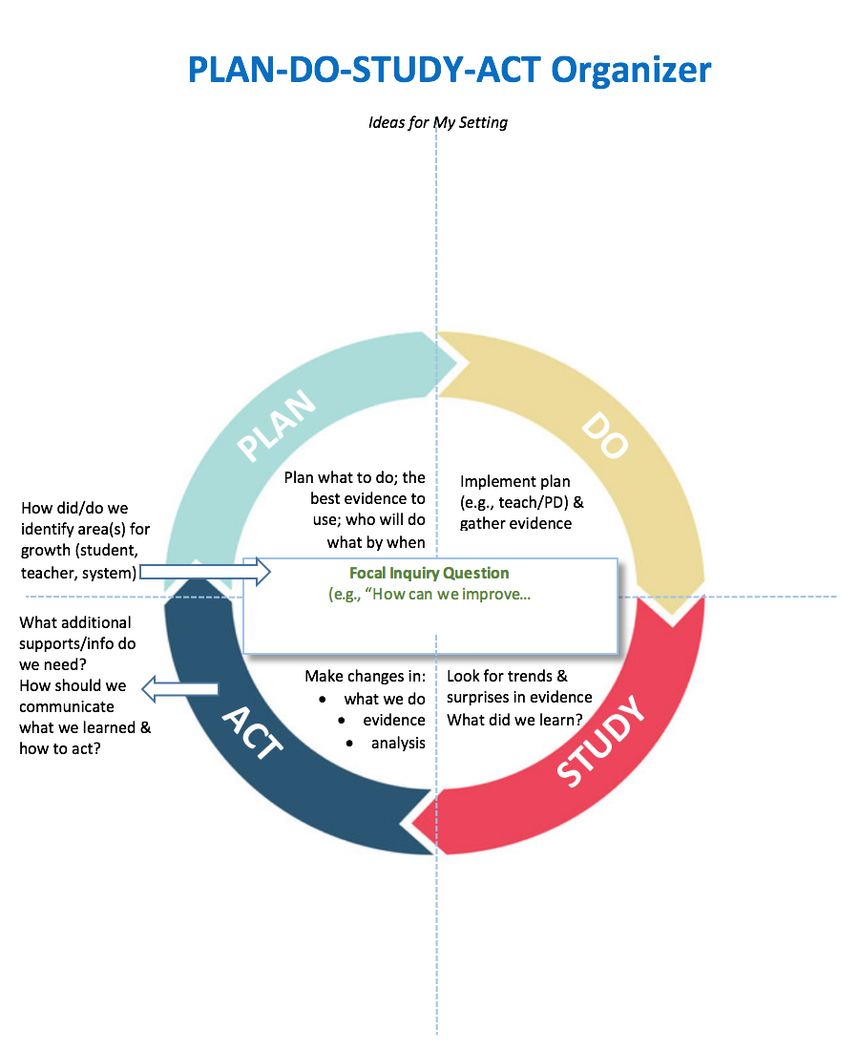

Notes:

Notes:

Notes:

Notes: