Member Customization Considerations

(Members: Delete this page before distributing)

The Tools for Teachers: Help Desk Guide provides guidance for accessing and navigating the Tools for Teachers web application. It is expected that all members will need to customize this manual to meet the needs of their specific state/territory, by including state/territory policies and procedures, member contact information, and/or preferential edits. Throughout this guide, members will see highlighted text. This indicates that members should customize the section/topic according to state/territory policies and procedures. Members may edit the rest of the guide in sections that are not highlighted, but should send any such changes to Smarter Balanced in advance to mitigate risks to validity, reliability, or comparability.
Members will need to identify where they will house their information and update all links in the document with that member’s website or location.
Members should insert text and/or links in the following sections based on member preferences:
- Member state/territory point of contact (p. 4)
- Interim Assessment Item Portal access contact (p. 7)
- Multi-tenancy: member specific content if applicable (p.9)
- Member state/territory point of contact (p.10)
- Update Images with member footer information (p. 15)
- Member assessment portal link (p.27)
As members customize this document, page numbers throughout the document may shift. To update pages in the Table of Contents on Windows computers, type <Ctrl> + <a> to select the whole document, type <F9> to update fields, and then select the “Update entire table.”
New for Fall 2021:
- Instructional Resources quick link (p. 6)
- Interim Connections Playlist IAB button (p. 6)
- Interim Assessment Item Portal Access (p.7)
- Public Access Page Info (p. 10)
- Left-Hand Navigation Bar changes (p. 10)

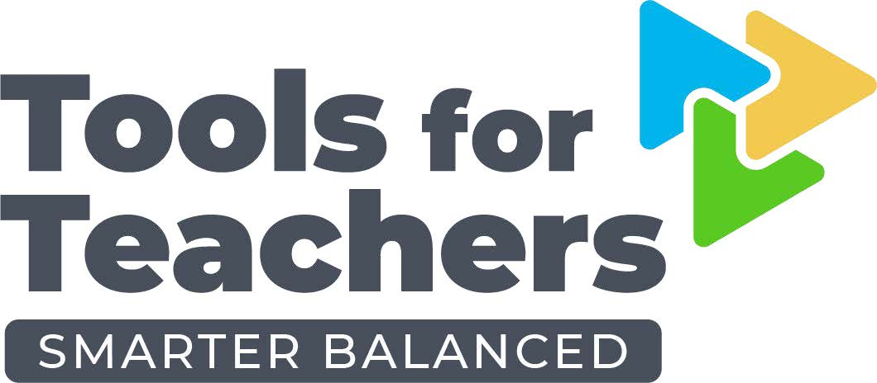

Tools for Teachers
Help Desk Guide

August 2021

Table of Contents
Table of Contents 2
Introduction to the Help Desk Guide 4
Customer Support and Help Desk Services 4
Tier 1 Support 4
Tier 2 Support 4
Tier 3 Support 5
Tools for Teachers Overview 6
Instructional Resources 6
Interim Connections Playlists 6
Interim Assessment Item Portal 7
Professional Learning Resources 7
Formative Assessment Strategies 7
Accessibility Strategies 8
Multi-Tenancy & Public Access 8
Public Access Pages 10
The Left-Hand Navigation bar 10
Tools for Teachers Site Navigation 14
Site Footer 14
Home Page 16
Home Page Search 16
Search Results 17
Resource Features 18
Resource Outline 18
Resource Metadata 18
Attachments 19
Embedded Strategy Links 20
Note Taking Feature 20
Share Feature 22
Bookmark Feature 22
Print Feature 23
Readability Mode 24
Log Out 24
User Messages 25
Login Prompt 25
Public/Not Authenticated User 25
Tenant Restricted Resource 26
Resource Inactive or Does Not Exist 26
Accessing Tools for Teachers 27
Logging in through Assessment Portal SSO First 27
Logging in through Tools for Teachers First 27
Technical Troubleshooting 29
Internet Connection 29
Internet Browser 29
Screen Refresh 29
Clear Cache 29

Introduction to the Help Desk Guide
This document describes the features of the Smarter Balanced Assessment Consortium (Smarter Balanced) Tools for Teachers website. It is intended for individuals who manage member help desks. For specific questions not addressed in this guide, please contact State point of contact at XXX.

Customer Support and Help Desk Services
Smarter Balanced recommends that customer support and help desk services provide states with a unified, single point of contact for school, district, and state staff to contact for information regarding everything from general inquiries, such as password recovery, to assistance with technical issues that will need to be handled by systems engineers.
To support implementation, a state’s customer support and help desk solution will require Tier 1, Tier 2, and Tier 3 services. States and their service providers will need to provide Tier 1 and Tier 2 support. Smarter Balanced provides Tier 3 support for Tools for Teachers.
The Tiered Support framework from Smarter Balanced Assessment Consortium: Implementation Guide for States and Service Providers is summarized below.
Tier 1 Support
Tier 1 offers the first line of customer support, addressing the most basic customer issues (e.g., general inquiries, non-technical questions, password recovery, etc.). In general, Tier 1 support provides information that may be found in manuals. Smarter Balanced recommends that states determine what, if any, questions should be directed to the state instead of the Tier 1 help desk (e.g., policy questions).
Tools for Teachers Tier 1 examples include but are not limited to logging in, setting up an account, or searching for resources.
Tier 2 Support
Support Issues not resolved by Tier 1 support are automatically sent to Tier 2, which offers more in-depth technical support than Tier 1. Tier 2 customer support personnel are typically technicians who can assist with common, mid-level technical questions, such as local system setup, local network issues, or compliance with data and interoperability standards, as well as applying technical solutions to issues that have established resolution methods.
Tools for Teachers Tier 2 examples include clearing cache, updating browser settings, or printing a resource.
Tier 3 Support
Tier 3 requires the greatest level of technical expertise and addresses the most complex technical problems. Tier 3 issues are typically handled by systems engineers and other technical experts and may require multiple interactions with the customer before the issue is resolved.
Smarter Balanced recommends that during the procurement process, states request that service providers name the resource that will be responsible for managing customer service for the project (e.g., name of customer service manager or Program Manager) and, if applicable, the software or system used to manage inquiries and issues.
Tools for Teachers Tier 3 examples include fixing pages or content that is not loading or rendering, fixing the site when it is down, or fixing issues relating to unknown error messages or prolonged processing time.
Should Tier 3 support be needed, please submit a request for support at support@smarterbalanced.org. In your email, include:
- your name and organization,
- a short description of your issue,
- the date and time when the issue occurred,
- the system (Windows, Chrome OS, macOS, etc.) and browser (Chrome, Firefox, Edge, Safari, etc.) used,
- whether this is the first occurrence of the issue,
- any other users who are having the same issue,
- what steps have already been taken to troubleshoot the problem,
- any other Administrators or support tiers to whom this issue was reported,
- and attach screenshots of the problem or error message, if possible.

Tools for Teachers Overview
Tools for Teachers is a website with an extensive suite of educator-created and educator-approved resources with lessons and activities designed with the realities of classroom instruction in mind. It was developed using educator suggestions and feedback. The site is easy to use, accessible, and embedded with instructional and professional learning resources, which are contributed and reviewed by trained educators from Smarter Balanced members.
The resources in Tools for Teachers are embedded with scaffolds and strategies for implementing the formative assessment process and differentiating instruction within diverse classrooms. Member educators are provided access to a variety of classroom tools that can be used to support student success:

Instructional Resources
These are classroom lessons or activities that focus on essential concepts and skills within grade-level claims, targets, and standards. Instructional resources can be used to fill curriculum gaps, or to fill learning gaps identified through the use of an Interim Assessment Block (IAB) or through classroom observations and evidence.

Each instructional resource clearly identifies student learning goals and success criteria, providing step-by-step directions for classroom use, and is distinct for students at different ability levels. Additionally, it includes a description of how the formative assessment process is used in the resource and embeds formative assessment and accessibility strategies. It is reviewed and approved by grade-level educators prior to being added to the Interim Connections Playlists.

Each instructional resource includes a quick link to the Remote Teaching and Learning Framework Professional Learning Resource.

Interim Connections Playlists
Interim Connections Playlists connect Interim Assessment Blocks (IABs) with instructional resources. Interim Connections Playlists include a performance progression table that describes student performance expectations at each performance category (below, near, or above the grade level) and instructional resources designed to support instruction on each of the topics within the IAB.

Interim Connections Playlists are developed by a team of grade-level educators using student performance data, achievement level descriptors, and educator expertise to identify observable student performance progressions.

Interim Assessment Item Portal
Educators can access the Interim Assessment Item Portal (IAIP) to access the secure questions on the interim assessments. They can also access each of the corresponding interim assessment blocks directly from each of the Interim Connections Playlist with a button, if the educator is approved for access to the Interim Assessment Item Portal (IAIP). When a user selects the interim assessment button from the playlist, they will go to a pre-filtered search page in the IAIP that will display the individual items for that Interim Assessment Block (IAB).
The Interim Assessment Item Portal is only available for approved educators in each state. Member point of contact for access support at XXX. Educators who do not have access to the IAIP can use the Sample Items website is available publicly for all users.

Professional Learning Resources
These resources support teachers’ knowledge and skills related to the Smarter Balanced assessment system, such as understanding the formative assessment process, implementing IABs in the classroom in different ways, or understanding the reporting system.

Professional Learning Resources can be used by individual teachers, coaches, and professional learning communities.

Formative Assessment Strategies
These classroom strategies support educators in using the formative assessment process to clarifying intended learning, eliciting student evidence, interpreting thinking and learning by students and teachers, and acting on the evidence.

Each instructional resource is embedded with one to three formative assessment strategies.

Accessibility Strategies
These classroom strategies support educators with implementing accessible instructional practices with students in the classroom to meet diverse learning needs. Smarter Balanced interim and summative assessments utilize three tiers of embedded and non-embedded accessibility tools to make content accessible to all students: Universal Tools, Designated Supports, and Accommodations.

The accessibility strategies compliment these tiers of support by providing students with access to similar supports in the classroom. Additionally, accessibility instructional strategies are now available in Tools for Teachers that are intended specifically for instructional use and are not applicable to Smarter Balanced assessments. For each strategy, the right column lists the associated UAAG Tier for support; if the strategy is not available on assessments, the UAAG Tier will say “not applicable.” This right column also includes a category label to help educators identify strategies based on student needs (e.g., multilingual, culture, health, reading, calculation).

Each instructional resource is embedded with one to three accessibility strategies.

Multi-Tenancy & Public Access
The website was built using a multi-tenant approach. This means each member state or territory has options for customizing the user interface as well as the underlying database. Figure 1 represents the multi-tenancy model.
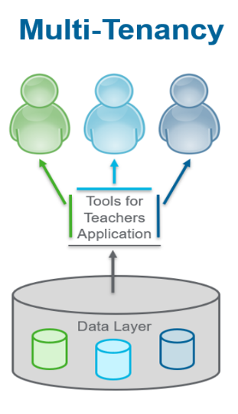
Figure 1:
A screenshot of multi-tenancy
Some options for member specific customization include headers, footers, logos, and hyperlinks. Educators (e.g., classroom teachers, coaches, administrators, or higher education faculty) can access Smarter Balanced sponsored resources aligned with state standards for English Language Arts and Mathematics content in grades 3–8 and High School.
For more information on the availability of Member-specific resources, please check with your state lead.

Public Access Pages
Tools for Teachers is part of a balanced assessment system and requires login access for member educators. To help users without an account get started, we offer both a teaser view (part of a resource) that will prompt users to log in. We also provide a minimum of two publicly available resource samples for each resource type (i.e., Interim Connections Playlist, Instructional Resource, Professional Learning, and Formative Strategies), these publicly available resources are available to users on the “Quick Start” information pages linked in the left navigation bar.
Please note that all of the Accessibility Strategies are publicly available. he Interim Assessment Item Portal is only available for approved educators in each state. Member point of contact for access support at XXX. The Sample Items website is available publicly for all users.
When supporting members with login support and to determine if they are on a public page or logged in, it is best to ask the user if they can see one of the following user interface descriptors to confirm if they are logged in or not:
- Member name is at the top of the home page in the Tools for Teachers icon
- The member department of education logo is in the footer
- The footer includes a list of links to member supports
- The lower left navigation bar has a bookmark

The Left-Hand Navigation bar
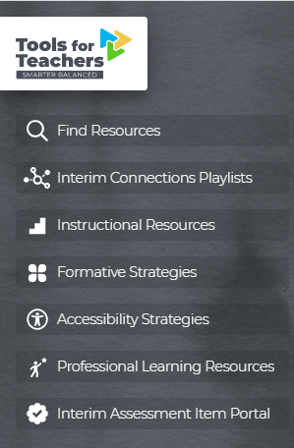
Figure 2:
The left-hand navigation bar.

Tools for Teachers Logo
When selected, directs the user back to the main search page.

Find Resources
Directs to the main search page.

Interim Connections Playlists
Directs to Interim Connections Playlists “Quick Start” page.
- Listen/Interpret (https://smartertoolsforteachers.org/resource/210)
- Geometry (https://smartertoolsforteachers.org/resource/226)

Instructional Resources
Directs to Instructional Resources “Quick Start” page.
- To the Moon: Finding Central Idea (https://smartertoolsforteachers.org/resource/126)
- What’s Your Angle? (https://smartertoolsforteachers.org/resource/1341)

Formative Strategies
Directs to Formative Assessment “Quick Start” page.
- Exit Ticket (https://smartertoolsforteachers.org/resource/19)
- Notice/Wonder (https://smartertoolsforteachers.org/resource/30)
- Stairs and Stairs (https://smartertoolsforteachers.org/resource/38)
- Thumbs Up/Thumbs Down (https://smartertoolsforteachers.org/resource/45)
- Mini Whiteboards (https://smartertoolsforteachers.org/resource/50)

Accessibility Strategies
Directs to Accessibility Strategies “Quick Start” page.
- All Accessibility Strategy resources are publicly available at https://smartertoolsforteachers.org/landing/accessibility.

Professional Learning Resources
Directs to Professional Learning Resources “Quick Start” page.
- Remote Learning and the Formative Assessment Process Framework and Template (https://smartertoolsforteachers.org/resource/1411)
- Smarter Balanced Ecosystem (https://smartertoolsforteachers.org/resource/406)

Interim Assessment Item Portal
Directs to Interim Assessment Item Portal “Quick Start” page.
The quick start page is public. Users must have permission to access the portal. Users who do not have access should use the Sample Items Website.

Bookmarks & Notes
Allows the user to access a personalized list of resources previously bookmarked. This list also includes resources used in the personalized notes feature.

Figure 3:
The bottom of the left-hand navigation bar.
Login/Logout
Log in or log out of Tools for Teachers as needed by selecting the button in the navigation bar and selecting your state from the member drop down menu.

Functionality
When the user’s mouse is not hovering over the gray section, the navigation bar will collapse:
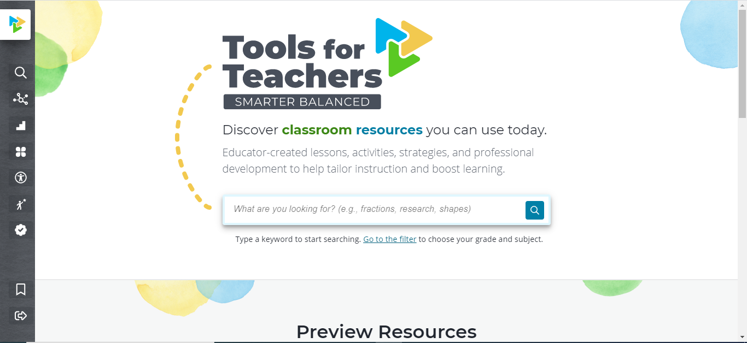
Figure 4:
A screenshot of Tools for Teachers homepage showing the closed left navigation bar.
In the closed view, only the icons are visible.
Once the user hovers over the gray bar, the navigation bar will expand to display added details (i.e., icons and labels) as displayed in Figure 3 below:
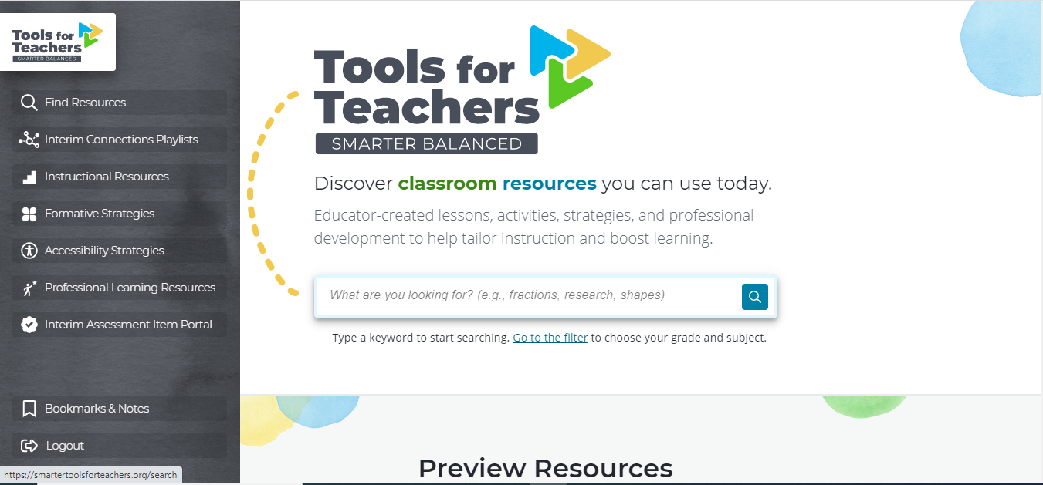
Figure 5:
A screenshot showing the open left navigation bar. In this view, the icon and descriptions are available.

Tools for Teachers Site Navigation
This section explains the common navigation features of Tools for Teachers.
- Users can navigate the site as non-logged-in users, but they will only have a partial and limited view of the resource.
- It is recommended that users log in before searching to ensure full member access.
Figure 6: A screenshot showing the home page of Tools for Teachers
Site Footer
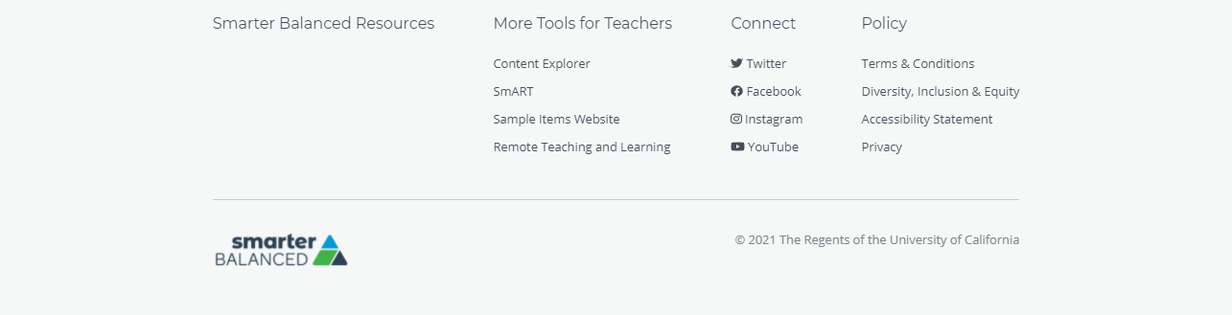
Figure 7: A screenshot of the bottom-of-page footer on Tools for Techers pages
A gray footer will always be present on every page. There are three areas within the public view footer:
- More Tools for Teachers
Provides access to other resources in the Smarter Balanced ecosystem.
- Connect
Presents the user with links to the various social media accounts for the user's organization.
- Policy
Provides links to the Smarter Balanced Terms & Conditions, Accessibility Statement, and Privacy policy.
When logged in, a fourth area is added with state specific links. Member states/territories can customize the links in their state resource section as displayed in Figure 8.
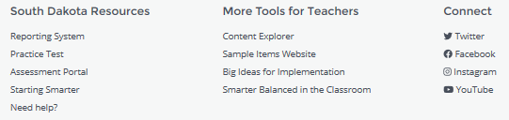
Figure 8:
A screenshot of a member footer with four areas showing member-specific resource links.

Home Page
The home page contains a left-hand navigation bar that includes a quick search for both accessibility and formative strategy resources, a search bar, a link to filter resources, two preview resources that do not require a login for full access, and two Smarter Balanced videos as displayed in Figure 9.
Figure 9: A screenshot of the main search home page
For optimal results, it is recommended that a user is logged in prior to searching in order to have access to all the resources available in the user's state/territory.
Home Page Search
The search functionality is the primary method for users to access Tools for Teachers content and was created to serve three primary instructional use cases:
- known gaps in instructional materials
- observable gaps as the result of an interim assessment
- observable gaps as the result of classroom observations
In addition to searching specifically for instructional materials, users search Tools for Teachers for formative and accessibility strategies, professional learning resources, and interim assessment items. There are three strategies for making a search more effective:
Keyword Search: The keyword search feature allows educators to jump right in and type what they are looking for. A list of search results will display once the user selects the search icon or presses the enter key. The search algorithm uses an additive approach, sometimes called fuzzy logic, which means that if you type in summarized text, you will get results for everything related to what you typed. This allows a user to spell a word wrong, transpose letters, or use a different form of a word.

Filter Resources: This feature allows educators to filter resources based on the resource type, grade, content, claim, target, and/or standard. Results are updated according to the selection of corresponding filters. For each selection made, the button’s plus sign will turn to a minus sign, and it will go from light blue when it is not selected to a darker blue when it is selected.
The filtered search is hierarchical. Meaning that once a selection is made it will only provide the next available filter in the hierarchy. For example, when selecting the filter for an English Language Arts resource, the advanced filters will reset and only provide available resource type and grade selections based on the previous selection.
To clear filters, the users can deselect selected filters individually, or they can clear all of the filters using the “clear filters” button in the upper right corner of the search filter box.

Combined Keyword & Filtered Search: The keyword and filtered search features can be used together. This allows for educators to widely search resources using keywords and phrases, and then use the available filters to narrow results. Using the combined search features together can provide users a more customized search experience.

Search Results
The keyword search uses an algorithm to render results based on relevance. This algorithm weights words and phrases in the key word search as they appear in the title, metadata, and the resource content. This score is used to determine the relevance, and therefore display order, of the resource in the search results.

Users can filter by content, grade, claim, target, and standard. If a resource does not have the applicable filter, then it is not available to select. For example, Formative Strategies are not tagged with specific content or grade levels, so the filters for these categories are not available if a user filters by a resource type. For each filter selection, the search results are updated.

A list of search results will display once the user selects the search icon, presses enter using the keyword search, or in real time as the user selects (and deselects) filters. A result counter shows how many resources are rendered. For example, “Found 12 resources.” Scroll down to view search results.

The search results list each resource available as displayed in Figure 10. The results card includes: The resource type, title, description, and any metadata connected to the resource (e.g., grade, content, claim, target, and standard). Not all resources include additional metadata.
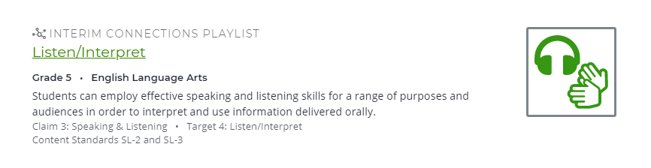
Figure 10: A resource card that appears in search results

Resource Features
Tools for Teachers has several distinct features to make resource navigation efficient. These features allow users to quickly navigate and use content.

Resource Outline
Within each resource, the user has the ability to access the resource outline on the left-hand panel. This outline provides an overview of the major sections in the resource.
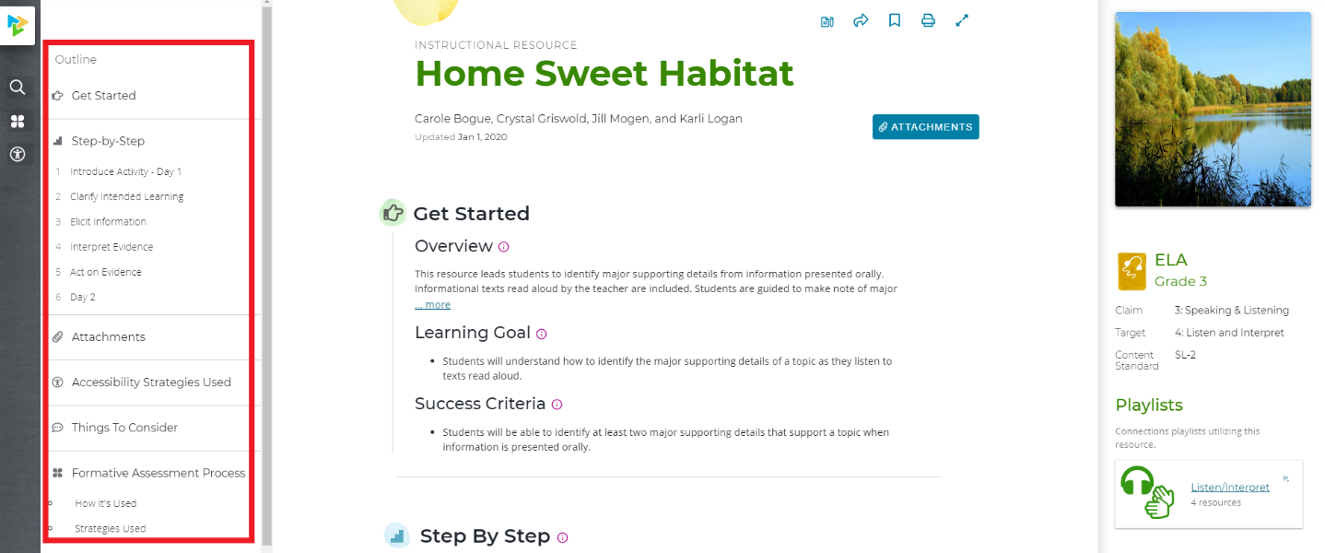
Figure 11: A screenshot of the outline in the left margin

Resource Metadata
Tools for Teachers also displays important metadata, or summary information, about each resource in the right-hand panel. This data, as displayed in Figure 8, includes subject, grade, claim, target, content standard, and the associated Interim Connections Playlist.
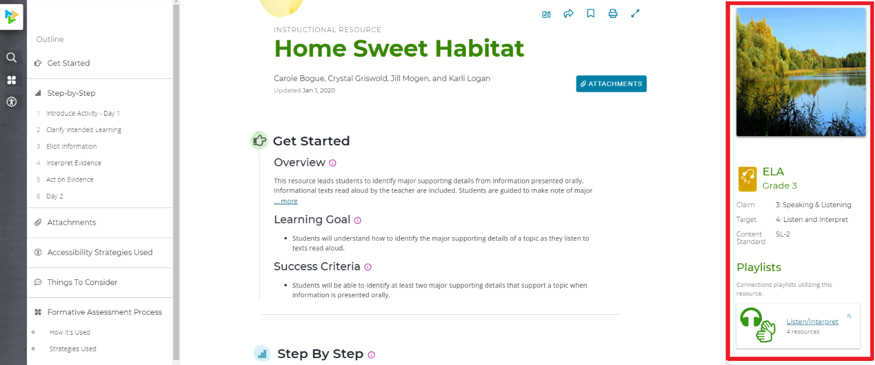
Figure 12: A screenshot that shows the metadata about this resource in the right margin

Attachments
Attachments include a variety of teacher and student materials to support classroom instruction. To view and download the attachments, select the attachment tab with the paper clip icon at the top of the resource, the attachment link in the left-hand navigation bar, or by scrolling down to the attachment section of the resource. The attachment link and feature are displayed in Figures 13 and 14. 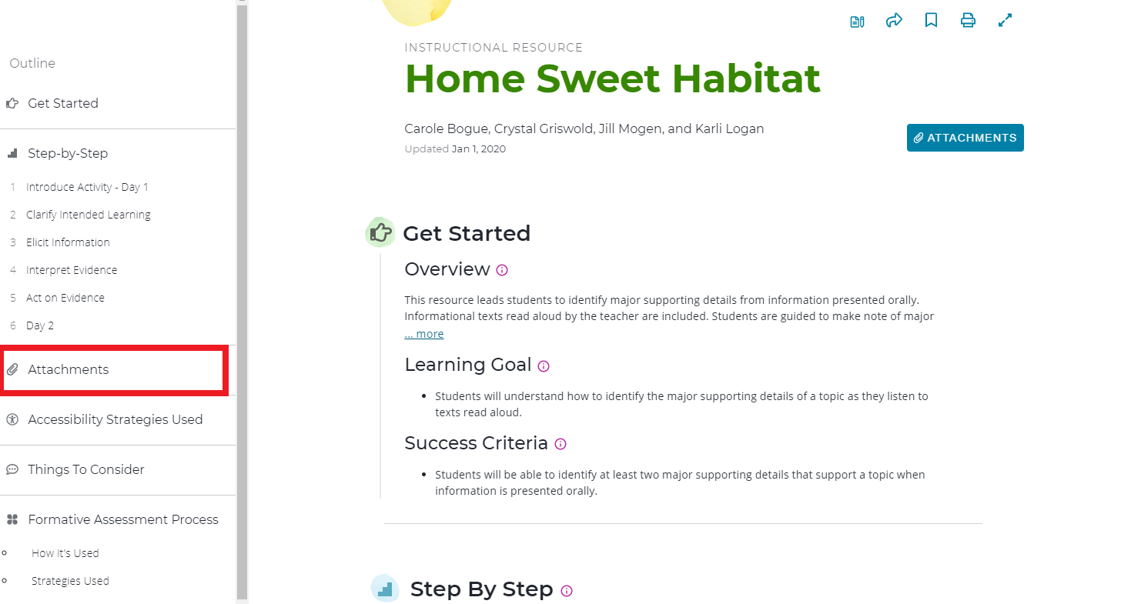
Figure 13: A screenshot of the attachment link in the outline in the left margin and top right of the resource
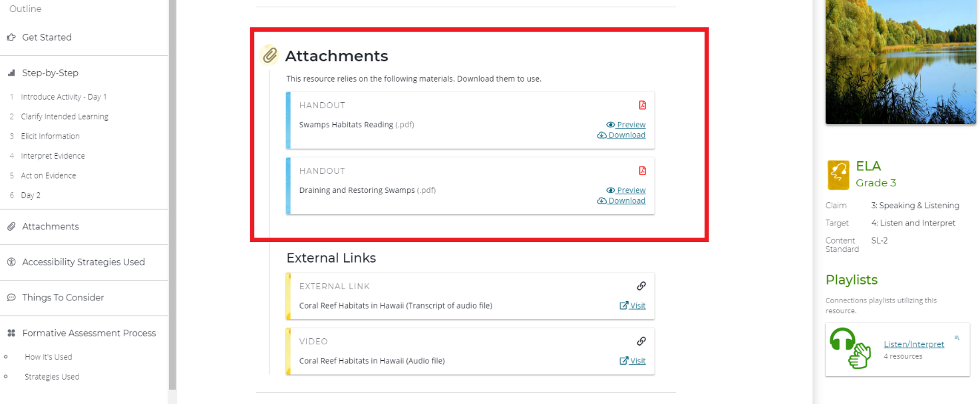Figure 14: A screenshot of the attachment in the center column of an instructional resource

Embedded Strategy Links
When a Formative Assessment or Accessibility Strategy is referenced within another resource, a reference link is provided which will take the user to the specific strategy resource for more information. Reference links are shown in purple font along with the distinct icon for each strategy. Formative Assessment Strategies use a clover icon, and Accessibility Strategies are represented by a person in a circle icon.
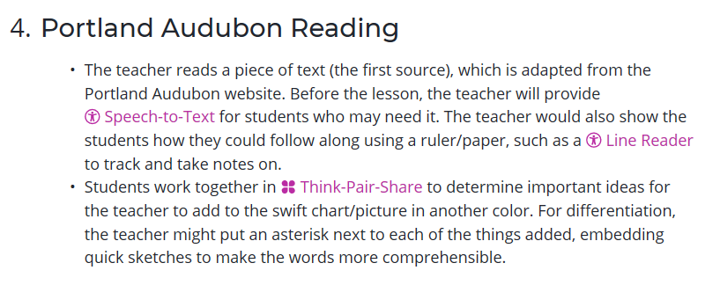
Figure 15: A screenshot that shows embedded formative and accessibility strategies

Note Taking Feature
Tools for Teachers allows a logged-in user to add notes to a resource, so that they can recall personal details about a resource at a later date/time.

Adding a Note
To add a note, a user selects the notes icon located at the top of each resource as displayed in Figure 12. A notes panel will appear on the right-hand side.
Select “+ Add your first note,” type in your notes, and select save.
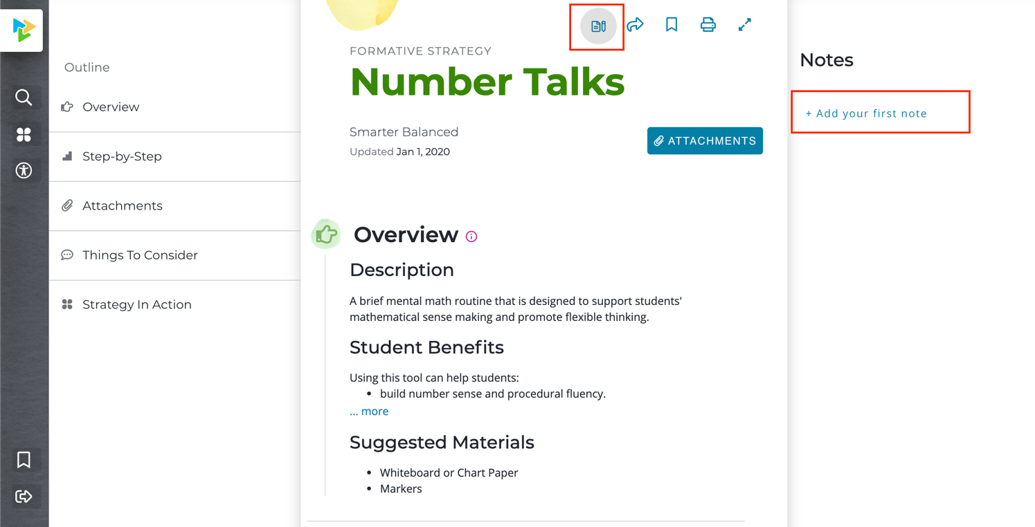
Figure 16: A screenshot of the notes feature with notes in the right-hand margin

Accessing Notes
A user can access their notes in two ways:
- Within the left-hand navigation bar, select Bookmarks & Notes as displayed in Figure 13, then select the desired resource.
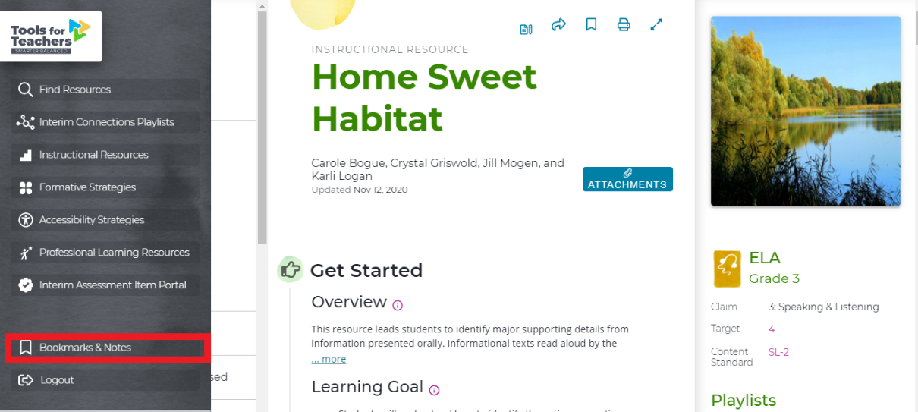
Figure 17: A screenshot showing the Bookmarks & Notes icon in the lower left corner of the left navigation bar
- Search for the desired resource and select the notes icon.

Share Feature
To share a resource, select the share “curved arrow” icon at the top of the resource page as displayed in Figure 14. This opens a pop-up window displaying a link the user can copy to the clipboard. The user could then paste the link into an email to share the resource with a colleague.
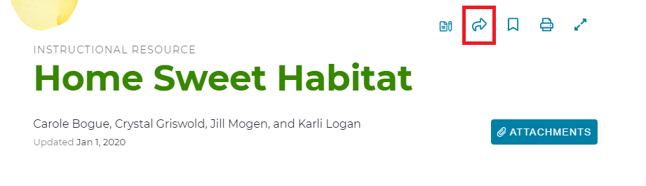
Figure 18: A screenshot showing the curved arrow icon used to select and share a resource

Bookmark Feature
Tools for Teachers allows a logged-in user to “Bookmark” their favorite resources. This allows a user to save resources for quick access later when they log in to the site again.

Adding and Removing a Bookmark
To bookmark a resource, a user will select the bookmark icon at the top of the resource page as displayed in Figure 15. To remove a bookmark, select the bookmark icon again.
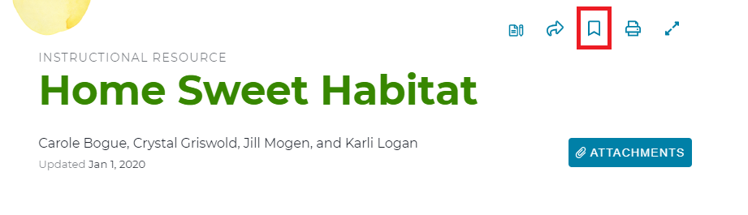
Figure 19: A screenshot of the bookmark icon at the top of the page
- When the icon is filled, the resource is bookmarked.
- When the icon is not filled, the resource is not bookmarked.
Note: The user must be logged in to Tools for Teachers to access this functionality.

Print Feature
To print a resource, the user selects the print icon at the top right of the resource page as displayed in Figure 16.
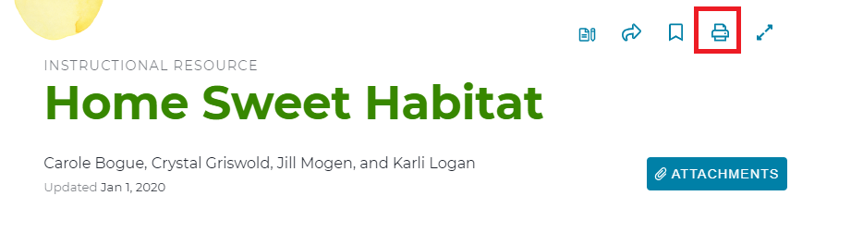
Figure 20: A screenshot showing the print button in the top icon menu
A print panel will appear on the left-hand side as displayed in Figure 17. The user can print the entire resource or select which sections within the resource outline they would like to print.
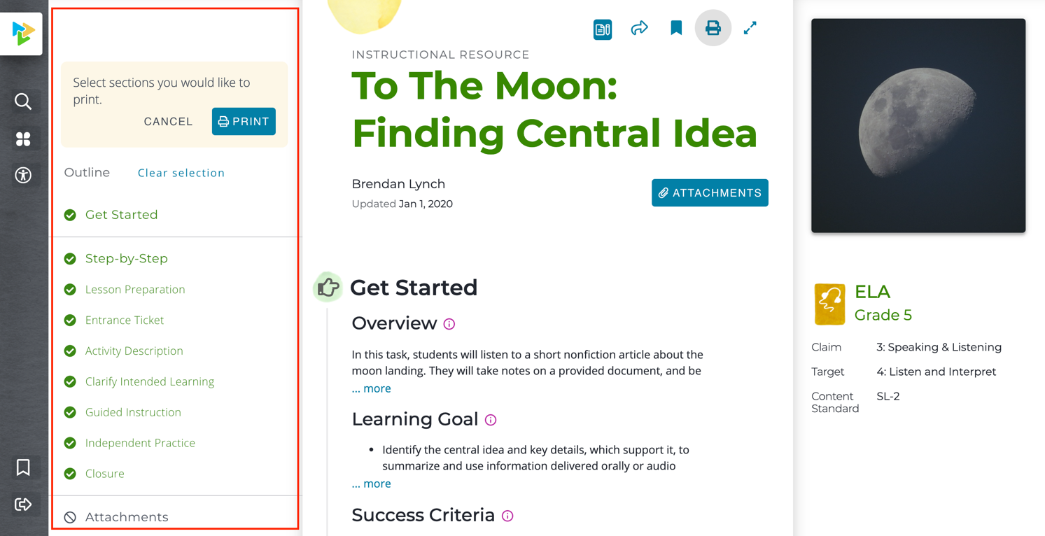
Figure 21: A screenshot of the print feature with the print selection options in the left margin
Note: Each browser (Chrome, Safari, Firefox, and MS Edge) has different print settings and operates uniquely. If provided, select “print header or footer” option to have access to the complete resource.

Readability Mode
Tools for Teachers allows the user to hide the navigation and metadata panels—this is called Readability Mode. To enter Readability Mode, select the “expanding arrows” icon on the top, right-hand corner of the middle panel of each resource as displayed in Figure 18.
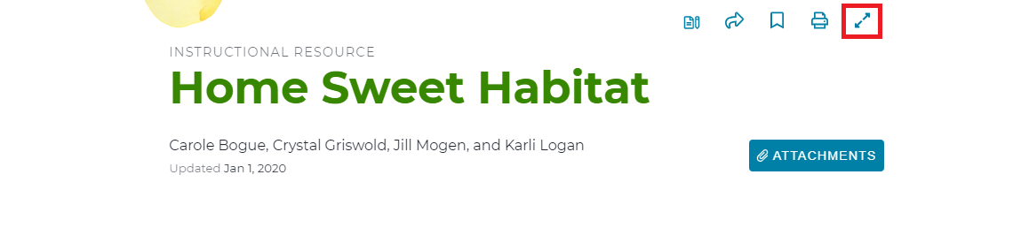
Figure 22: A screenshot showing how to access the readability mode at the top of the page. The icon is a double ended arrow

Log Out
Users may log out by selecting the left-hand navigation bar and selecting “Logout” as displayed in Figure 23.
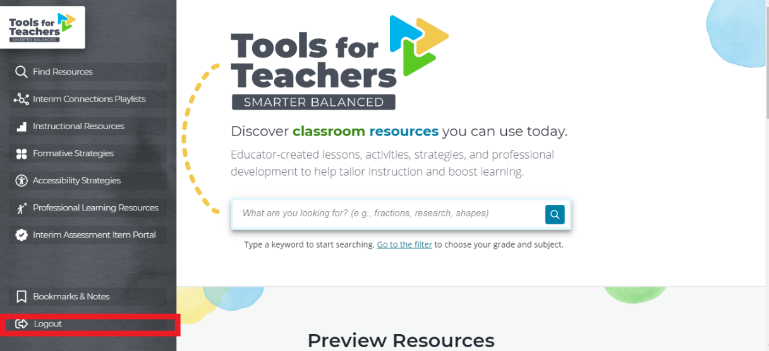
Figure 23: A screenshot of the left margin with “Logout” highlighted in the lower left corner

User Messages
The following messages will assist educators as they navigate Tools for Teachers.

Login Prompt
The message in Figure 24 appears when a user is in “public view” mode and instructs the user to log in to view the full resource.
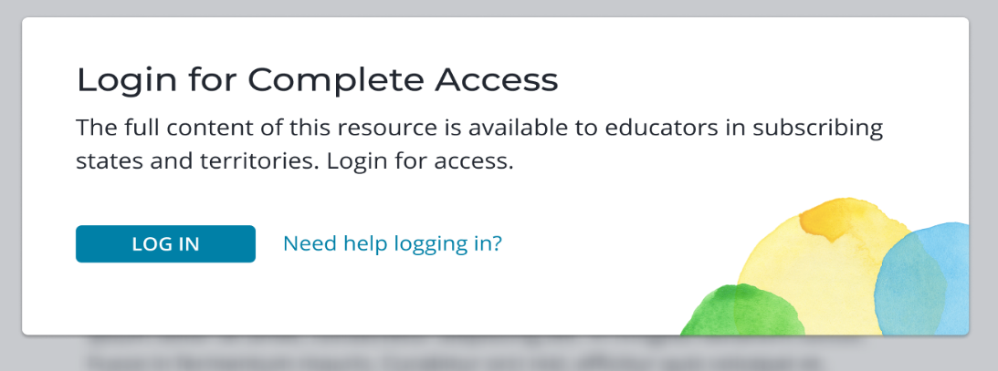
Figure 24: A screenshot of the log in prompt when a user has not yet logged in

Public/Not Authenticated User
The message in Figure 25 appears when a user tries to access a “tenant specific” resource, but they are not yet logged in. It instructs the user to log in to view the full resource.
Service Provider details: Tenant restricted resource.
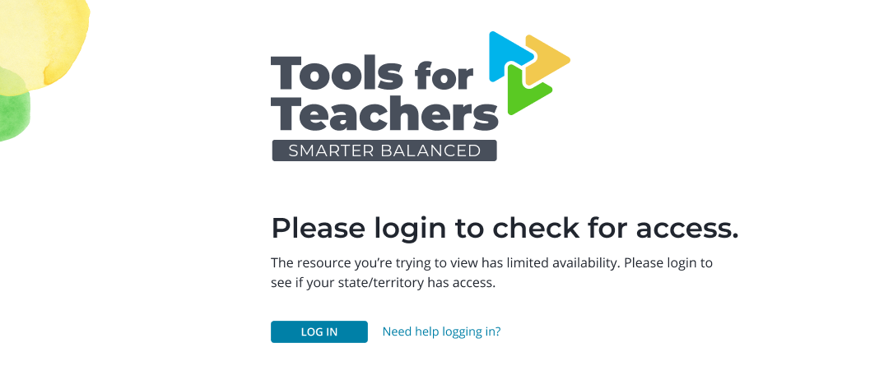
Figure 25: A screenshot of the message that prompts the user to log in to check for access to a tenant specific resource

Tenant Restricted Resource
The message in Figure 26 appears when a user tries to access a “tenant specific” resource, but they do not have access to a particular resource. For example, the tenant specific resource may only be available to a single member state (e.g., California), and an educator from another member state (e.g., Connecticut) is trying to access the resource. The tenant specific resource is not available to the user at this time.
Service Provider details: Unauthorized to access this resource.
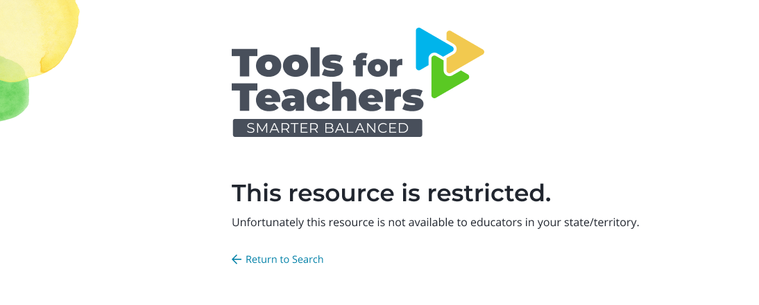
Figure 26: A screenshot showing a message that a resource is restricted

Resource Inactive or Does Not Exist
The message in Figure 27 appears when a user tries to access a resource that is not available.
Service Provider details: Resource with ID not found.
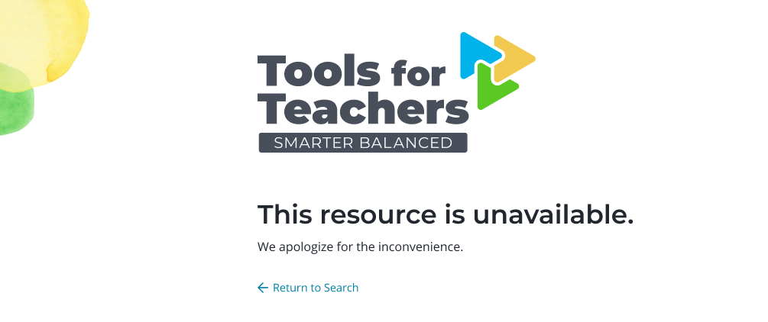
Figure 27: A screenshot of message that a resource is not available

Accessing Tools for Teachers
Educators can access Tools for Teachers content if they belong to an eligible institution (i.e., state, territory, or district) and that institution has provisioned their account for Tools for Teachers access. Once the institution grants access, authorized users can login to Tools for Teachers using their institution’s single sign-on (SSO)—that is, the same username and password that they use to access their institution’s assessment services, such as interim assessments and reporting (e.g. TIDE, MyToms, etc.).
Users have two options for logging in to Tools for Teachers:

Logging in through Assessment Portal SSO First
Member assessment portal link [member insert link here]
Users can access Tools for Teachers content by first navigating to their assessment portal and logging in with their SSO username and password. Because this account is the same one used for Tools for Teachers, users will automatically be logged in to Tools for Teachers once they navigate from their assessment portal to the site. They can do this either by selecting a link from the assessment portal (if configured by the institution) or by manually navigating to SmarterToolsForTeachers.org.

Logging in through Tools for Teachers First
If users navigate to Tools for Teachers without first logging in via the assessment portal, they will have limited access to content until they log in. To help users who have come without logging in first, the site has multiple methods of directing users to login:
- Main menu login button: In the left gray sidebar, the arrow icon at the bottom will initiate the login process from any page on the site.
- Search login prompt: Users who attempt to search before logging in will be prompted to log in so that they can see all content available to them. Note that content specific to a single tenant (i.e., a state or district) will not appear in search results for unauthenticated users.
- View complete content prompt: If a non-logged in user accesses a preview resource, the user will be asked to log in to view the full content beyond the initial preview.
- View restricted resource prompt: If a non-logged in user attempts to access a resource specific to a single tenant (e.g., California), the user will be asked to log in to ensure they have permission to view that resource.
In all of these cases, the login process users follow is the same:
- Selecting “Login” will send users to a screen asking them to select their location.
- After selecting their location, the site will direct them to their specific SSO.
- They will login using their SSO username and password.
- After successfully logging in, they will automatically be brought back to Tools for Teachers authenticated and able to access the complete content available to them.

Technical Troubleshooting

Internet Connection
Ensure the user is connected to the internet.
Indication of no connection:
- Windows: Mac:
Indication of need to select a wireless network:
- Windows: Mac:
Indication of connection:
- Windows: Mac:

Internet Browser
Tools for Teachers supports the following browsers:
- Chrome
- Edge
- Safari
- Firefox
Note: We recommend using a laptop or desktop computer to access Tools for Teachers. While the site is accessible via tablet devices, a laptop or desktop computer provide the best experience.

Screen Refresh
To refresh the screen, select adjacent to the address bar in the browser window.
Note: the refresh icon and placement are different for each browser.

Clear Cache
Refer to the wikiHow How to Clear Your Browser’s Cache for tips on how to clear a browser cache.

